Hamza Naeem

17-Arid-0240

Distributive database system

Database:

# Tables:

## Staff Table:

This table is used to manage Administrators for the purpose of logging and managing the records, A new admin can be added through SQL server but not through the software as the security may be sacrificed.

create table staff(id int,name varchar(30),passwrd varchar(36), contact varchar(20))

select * from staff

## Student Table:

The student table is meant to be used for the purpose of assigning new hostelers, managing the hostelers, and take record of rooms assigned / available in our hostel management.

create table student(id int,name varchar(30),religion varchar(20),nationality varchar(20),dob varchar(20),contact varchar(20),gender varchar(2),intake datetime, email varchar(20),rental int)

select * from student

## Room Table:

Room Table manages the type of rooms our hostel system offers i.e. one-seater, two-seater, etc. moreover the status of rooms whether the room is available or reserved or even under maintenance, this control is remoted by Admin and can be used to assign room.

create table room(id int,room_type varchar(20),room_status varchar(20))

select * from room

# Procedures:

## **Insert student:**

This procedure is used to insert/register a new student/hosteler in our database.

create proc ins_stud(@id int,@name varchar(30),@rel varchar(20),@nation varchar(20),@dob varchar(20),@contact varchar(20),@gen varchar(2),@mail varchar(20),@rental int)

as

begin

declare @in datetime

set @in = getdate()

insert into student values(@id,@name,@rel,@nation,@dob,@contact,@gen,@in,@mail,@rental)

end

**A sample execution is given below:**

execute ins_stud 2,'farzan','hindu','pakistan','15/3/1999','090078601','M','farzan@hotmail.com',3

## **Update student:**

This procedure helps upgrade student information, already exist in our system, based upon the id assigned.

create proc update_stud(@id int,@name varchar(30),@rel varchar(20),@nation varchar(20),@dob varchar(20),@contact varchar(20),@gen varchar(2),@mail varchar(20),@rental int)

as

begin

update student set name=@name,religion=@rel,nationality=@nation,dob=@dob,contact=@contact,gender=@gen,email=@mail,rental=@rental where id=@id

end

**A sample execution is given below:**

execute update_stud 2,'rehan','christian','pakistani','1/3/1999','090010133','M','rehan@gmail.com',3

## **Delete Student:**

This procedure helps delete a record from database which unable to pay bills or decline order at the exact time. Deletion is done with respect to id assigned.

create proc del_stud(@id int)

as

begin

delete from student where id=@id

end

**A sample execution is given below:**

execute del_stud 2

# Triggers:

## **Insert trigger:**

Create TRIGGER INS_CUSTOMER ON STUDENT INSTEAD OF INSERT

AS

BEGIN

DECLARE @ID VARCHAR(30);

SET @ID = (SELECT ID FROM inserted)

IF(EXISTS (SELECT * FROM STUDENT WHERE ID=@ID))

PRINT 'ALREADY EXISTS'

ELSE

INSERT INTO STUDENT SELECT * FROM inserted

END

## **Delete trigger:**

Create trigger del on student after delete

as

begin

Select * from deleted

End

Forms

# Login form:

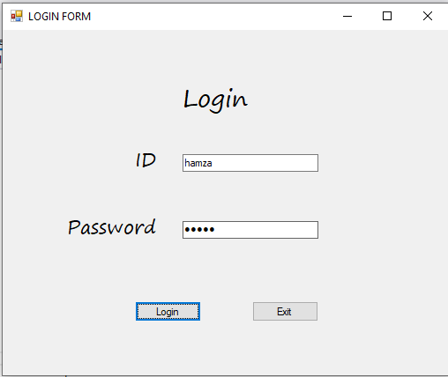 Login Form is the most initial form which is directed to the staff table through which only admin can access through and the process will go on.

## Main Menu:

After successful login, main menu will appear through which other information can be accessed, the main menu is further categorized as:

### Student Registration:

The form which is use for access of Student Table, A new hosteler is added up through this table.

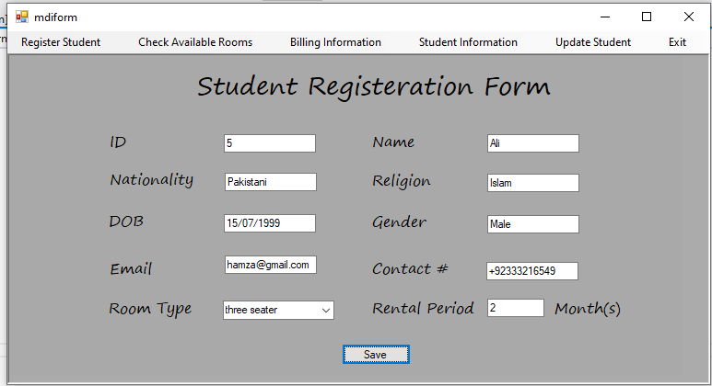

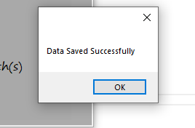After save button is clicked, A pop-up will be displayed if data will be saved successful.

### Room info:

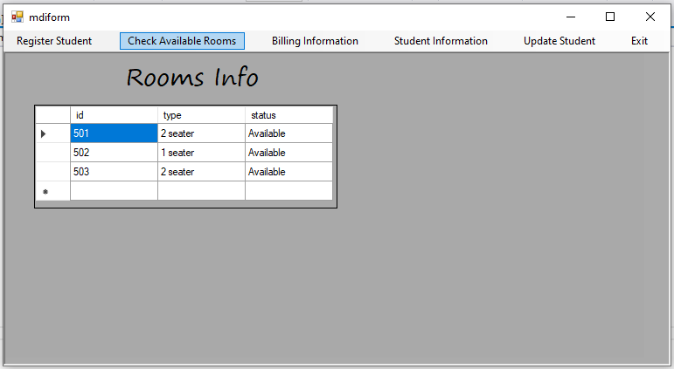 Room info refers to the information regarding to the availability of room directly accessed by the Room table, this information can be seen on load screen function.

### Billing Information:

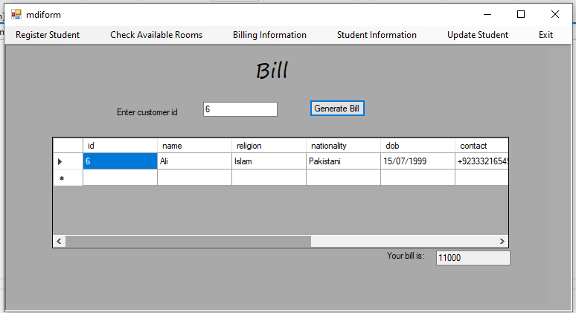 By entering the id assigned to the hosteler, bill will be generated regarding to the room type and rental period he/she will be staying.

### Student Information:

Student Information table will show all the records inserted in the history, through the help of this table, bill can be generated in case of forgotten id assigned to student.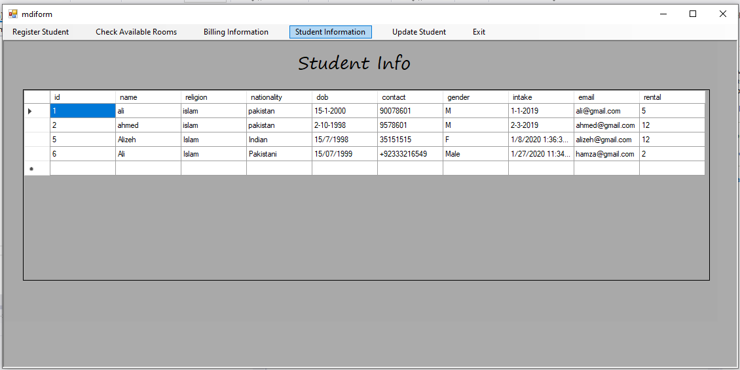

### Update Student:

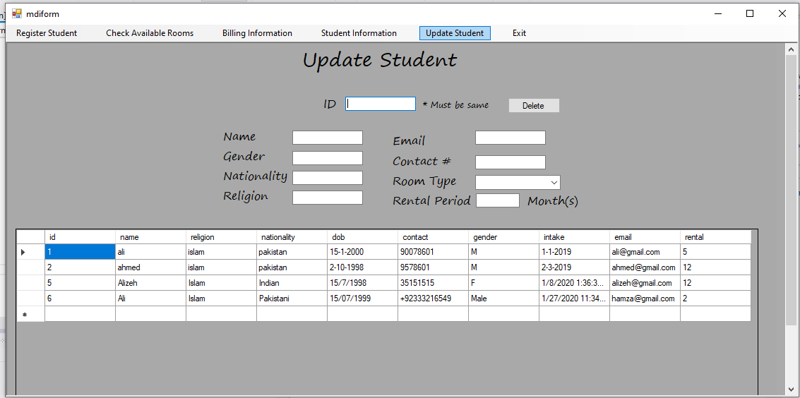 Update table refers to student table data inserted, this table helps to delete a record or to update information of a student.